Cancer Information
John Smith

Table of Figures
Table 1. Cancer-related deaths 1990-1998 5
Figure 1. Prostate cancer deaths 6
Figure 2. Female breast cancer deaths 7

Cancer Overview
Cancer is one of the scariest words in the English language. When you hear the word as part of a diagnosis, it’s natural to feel many emotions, especially fear.

What is cancer?
Cancer is a disease that occurs when cells in the body begin to divide at a faster rate than the body requires. These rapidly dividing cells grow into a lump that is known as a tumor. The tumor can be benign (non-cancerous) or malignant (cancerous).

What are the causes of cancer?
Many factors can cause the development of cancer in the body. Some of these factors, such as heredity (family members who have the disease) cannot be avoided. Others, such as lifestyle, can be controlled.

Other primary causes of cancer include:
Diet/nutrition — The proper diet is always important, but a poor diet might also increase your risk of cancer. For instance, eating large amounts of high-fat foods can contribute to cancer of the colon and prostate. Exercise is also key. Excess weight might be a contributing factor for various types of cancer, including breast, uterus, ovary, prostate, and colon.

How is cancer diagnosed?
If your doctor thinks you might have cancer, he or she will examine you and might order certain tests, including:

Biopsy (A procedure in which the doctor takes a small sample of the tumor and analyzes it under a microscope.)

What is staging?
One of the biggest concerns about a cancer diagnosis is whether the cancer has spread (metastasized) beyond its original location. To determine this, the doctor assigns a number (I through IV) to your diagnosis. The higher the number, the more the cancer has spread throughout your body. This is called "staging." The doctor needs this information in order to plan your treatment.

What are the treatments for cancer?
In order to treat your cancer, your doctor needs to know the location of the tumor, the stage (whether it has spread), and whether you are strong enough to handle the treatment.

What are the side effects of cancer treatments?

Chemotherapy — Side effects include hair loss, fatigue, nausea, vomiting.
Radiation — Side effects include fatigue, hair loss, skin problems (darkening, dryness, itchiness).
Surgery — Pain and weakness are possible side effects of surgery.

What other resources are available?
If you are diagnosed with cancer, it’s important to realize that you are not alone. You have your family and friends, and there are support groups for nearly every type of cancer. Ask your doctor for information about these groups. You can also contact your local chapter of the American Cancer Society for more information.

In addition, your doctor can refer you to a social worker or a mental health professional, both of whom can help you deal with the emotional aspects of your diagnosis. The social worker can also help you with the practical and financial issues related to the disease.

Diagnosis

This section of the Cancer Trends Progress Report - 2005 Update provides data on the rates of new cancers, based on the NCI Surveillance, Epidemiology, and End-Results (SEER) Program, by cancer site and by racial and ethnic group. Also included are data on the proportion of cancers diagnosed at a late stage for five of the major cancer sites where cancer screening has been shown or has been evaluated to make a difference in outcomes. Cancer sites include: female breast, colon, rectum, cervix, and prostate.
Source: (Cancer)

Cancer: Choosing a Treatment Program

See also the section titled What are the treatments for cancer?
What are the different kinds of cancer treatment?
Source: http://familydoctor.org

Statistics

Table 1. Cancer-related deaths 1990-1998
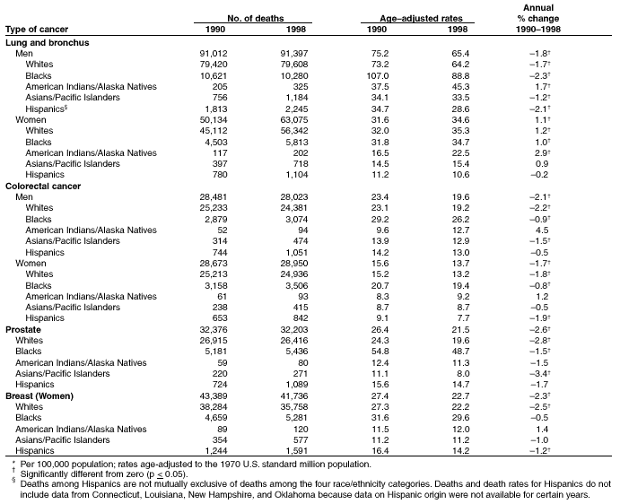

Figure 1. Prostate cancer deaths
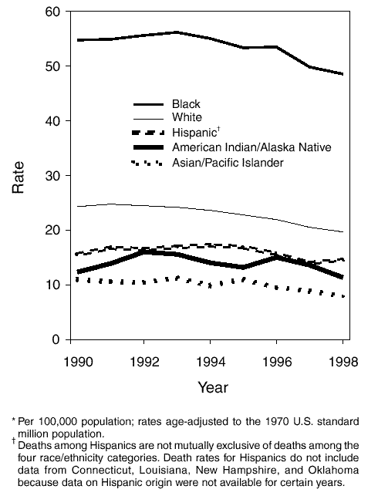

Figure 2. Female breast cancer deaths
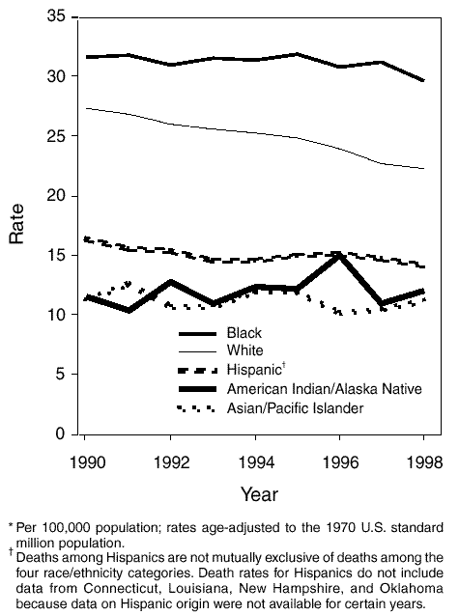

Tobacco and Cancer
Smoking damages nearly every organ in the human body, is linked to at least 10 different cancers, and accounts for some 30% of all cancer deaths. And it costs billions of dollars each year. Yet one in four Americans still light up. If you or someone you love uses tobacco, here's what you need to know about how tobacco kills, and how to get the help you need to quit.

Sun Safety

A sunburn will fade, but damage to deeper layers of skin remains and can eventually cause cancer. That's why sun-safe habits should begin in childhood and last a lifetime.

Food and Fitness

Eating right, being active, and maintaining a healthy weight are important ways to reduce your risk of cancer—as well as heart disease and diabetes. Learn the American Cancer Society's guidelines for diet and activity and find tips for a healthy lifestyle and community.

Early Detection

If you can't prevent cancer, the next best thing you can do to protect your health is to detect it early. Recognizing symptoms, getting regular check-ups, and performing self-exams are just a few ways you can do this.

Source: www.cancer.org

Bibliography
Cancer. (n.d.). Retrieved from www.cancer.gov

Source: (Cancer)

